Lab 3 Class UML Diagram

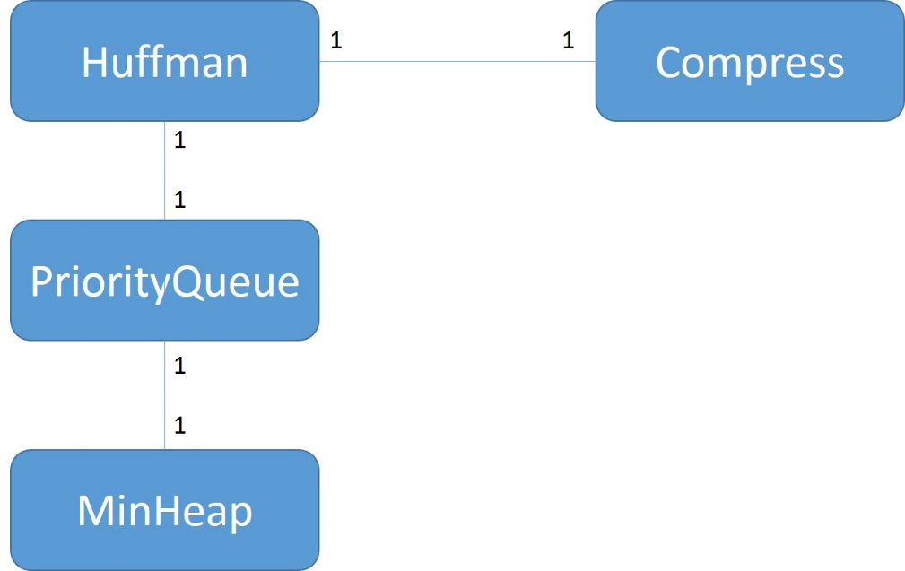

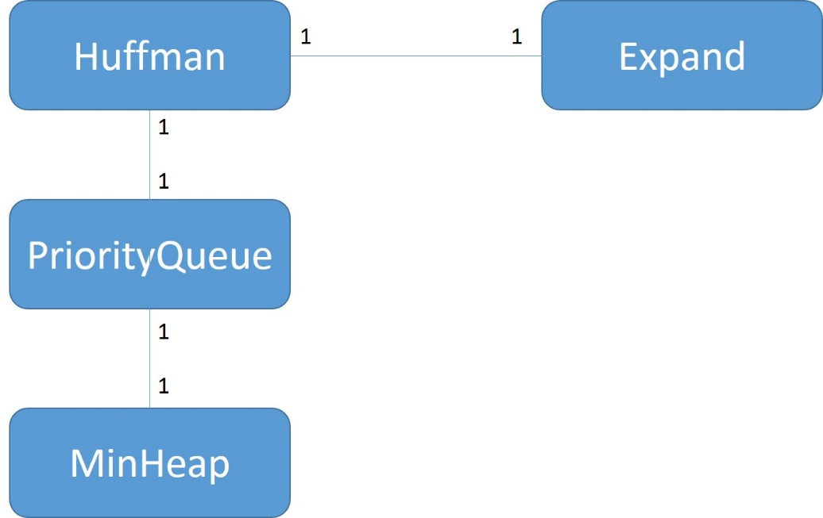

|  |
| --- |
| **MinHeap** |
| -HeapItem elements  -int iNumElements  -int iHeapLength |
| +struct HeapItem  +MinHeap()  +~MinHeap()  +void ReheapDown(int root, int bottom)  +void ReheapUp(int root, int bottom)  +bool Enqueue(int key, ItemType data)  +HeapItem *Dequeue()  +int getNumElements()  +printAll() |

|  |
| --- |
| **PriorityQueue** |
| -MinHeap<ItemType> *heap |
| +PriorityQueue()  +~PriorityQueue()  +bool Enqueue(int key, ItemType data)  +MinHeap* Dequeue()  +int getNumElements() |

|  |
| --- |
| **HuffMan** |
| -struct Node  -Node* rootptr  -unsigned char totalSymbolCount  -unsigned int totalUncompressedSymbolCount  -Node* frequencyTable[256]  -void calcEncoding()  -void deleteTree(Node*)  -void buildTree()  -void getSymbolFrequencies(ifstream& infile)  -void readSymbolFrequencyTable(ifstream& infile) |
| +Huffman()  +~Huffman()  +void Compress(const char* filename, const char* filename)  +void Expand(const char* filename, const char* filename) |

**Compress file structure**

|  |  |
| --- | --- |
|  | Compress file content |
| 1 | Total Symbol Count of Frequency table |
| 2 | Frequency table |
| 3 | Total uncompressed symbol count |
| 4 | Huffman Encoding |